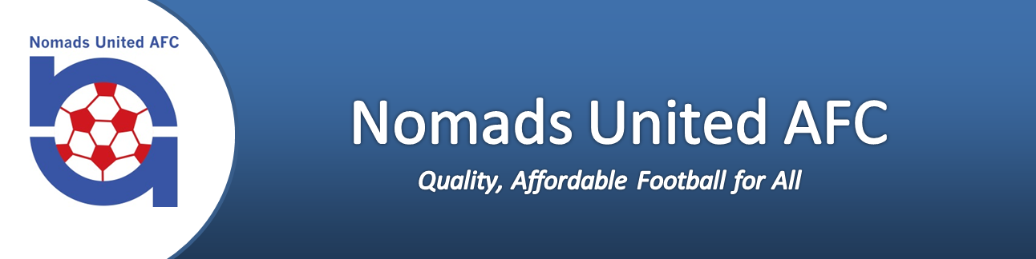

**First Kicks Football 2025**

**Information Sheet**

Welcome to **2025 First Kicks Football with Nomads United AFC**.

**First Kicks** Saturday mornings start at 9.30am-10:35am at Tulett Park.

**Starting Saturday 26th April 2025**

**Finishing Saturday 6th September 2025**

*Note there are no games scheduled for the 5th of July 2025(middle weekend of school holidays) and no games over Kings Birthday weekend (2nd of June 2025). There will be no games on the 21st of June 2025 (Matariki weekend).

The Nomads First Kicks programme emphasises the important of FUNand enjoyment whilst teaching the basic skills of football including football techniques and coordination. Playing with the ball and scoring goals are the main reasons why so many children enjoy football. In 2022 Nomads introduced a new gameday format which gives all children on the pitch the opportunity to as often as possible have the ball at their feet themselves, to take an active part in the game, to score goals and thus to have a personal sense of achievement.

**The key principles of the Nomads gameday format are:**

* 4v4 small sided games.
* Players regularly rotated, with everyone involved.
* No referees and minimal involvement from coaches and parents – let the kids play!
* Gameday ‘festivals’ rather than formal matches and leagues.
* Each team has a maximum of two substitutes.
* Goals can only be scored from inside the centre line.
* No goalkeepers.
* After each goal, both teams automatically change one player each.
* On game days, teams begin with a warm-up game, followed by a football technique or football coordination game supplied by the club. Teams will then play two rounds of matches for a maximum of 15 minutes each. This will provide players with the maximum opportunity to develop their skills and play against different opponents throughout the competition.

**First Kicks Gameday Format:**

**9:30am:** Warm-Up Game – (10mins) – Warm-up activity supplied weekly by the club.

**9:40am:** Football Technique or Football Coordination activity supplied weekly by the club (15mins)

**9:55am:** Warm-up ends, drink break & prepare for first game(5mins)

**10:00am:** Game #1 starts (15mins)

**10:15am:** Game #1 ends, drink break & change fields (5mins)

**10:20am:** Game #2 starts (15mins)

**10:35am:** Game #2 ends, home time J

An email will be sent out each week to all players prior to game day to let you know your starting field along with any other important updates that players need to be notified about. The starting draw will also be displayed each Saturday morning.

At 9.30am each team will have 10 minutes of a fun activities/ activation drill with the teams gameday leader followed by a 15-minute football technique or football coordination activity. The activities and drills are part the Whole of Football programme which the gameday leader will be sent out by the First Kicks and Fun Football Coordinator each week. The focus of the activities and drills is on the basic skills and is underpinned by the players having fun and enjoying the involvement within the sport. We encourage teams to work together to deliver these activities.

After the warm-up, each team will then play two15-minute games against another First Kicks Nomads United team, the first game being against the team that shared the pitch for the warm-up. Each game will be played without stoppage (i.e., no halftime, no changing sides). After the first game, teams will have a 5-minute break allowing for drinks and halftime snacks, as well as to move fields prior to their second game starting.

The primary objective of the “In House League” is to develop the basic skills of football; in this age group, the competition nature of the game should be secondary. The First Kicks session time/game will conclude at 10.35am.

**Gameday Leaders**

Nomads relies on volunteers to offer their assistance as Gameday leaders (one per team). Gameday leaders assigned to the First Kicks teams have volunteered their time and knowledge of football freely. Your assistance in getting your children on Saturday on time would be appreciated. Each gameday leader will be responsible for running and co-ordinating the team warm-up activity and aiding in the refereeing of each game (along with the oppositions gameday leader).

**Notification of Cancellation**

The decision to play will be made Friday evening based on the weather forecast and ground conditions for the next day. In extreme circumstances where the forecast changes overnight, decisions may be made Saturday mornings. Also check Facebook, and the website for any updates. If your child is unable to play, please advise your team leader/coach. Where possible, Nomads will endeavour to re-arrange missed sessions/games to alternative dates/times however please note that due to circumstances out of our control we may not be able to guarantee this for every missed session.

**Side Line Encouragement**

Side line encouragement of your child and other children is welcomed. Bad language or abuse will not be tolerated by players, gameday leaders or team supporters. Please alert the First Kicks and Fun Football Coordinator immediately if there are any instances of bad language or abuse, so they can be dealt with straight away at the park.

**What To Bring**

All children should be wearing white shorts, red socks, shin pads and football boots. Gear can be purchased at numerous sport stores around Christchurch and the club has a supply agreement with Ultra Football with discounted gear as well. **Please refer to uniform on our website for details on how to purchase**. All children will also need to bring their own water bottle, clearly labelled with their name and a warm top to wear for the cooler days. You also may wish to bring some energy food for your child. A mobile coffee provider will also be available at the grounds each week for purchase if you need a morning coffee fix! A percentage of the providers’ takings is donated back to the club which is a great support to us! The more coffee you drink, the more the Club benefits!

**Equipment Provided by Nomads United AFC**

Each gameday leader will be provided with a gear bag to use for the season and a bag of balls. The team leader will be accountable for the team balls provided. Team shirts and bibs should be allocated and need to be collected after each Saturday and washed by each team for the following week. Each field will be set up prior to the children arriving and there will be a notice board indicating which field your team is playing on with the Weekly Draw. Each team will utilise one goal and half the playing field for their warmup training.

**Basic Game Rules**

* Both gameday leaders will be on the field to manage the games and organise the children.
* The teams must operate 4 a-side approach and have rolling subs for the other two players.
* No goalies in First Kicks - the goal must remain free of any player during general play.
* No offside in First Kicks
* Goals can only be scored in the opposition’s half.
* When the ball is kicked by an opposing team member over your goal line, a normal goal kick will be taken, adjacent to the goal posts.
* When the ball is kicked by your own team member a corner kick; for First Kicks only a normal goal kick will be taken.
* When the ball goes out over the side line, a kick in instead of a throw in is encouraged, so all children get to kick the ball. (Not all children at this age are able to through a ball over their heads correctly).
* After a goal is scored, the game is re-started from halfway and each team must rotate 1 player.
* If the game needs to be stopped for any reason, a drop ball between two players will restart the game.
* All fair play rules regarding football are followed at this level.
* Encourage your children to play the ball when tackling and not the opposition player.

**Complaints & Issues**

If you have any complaints or issues regarding the In-House League, please bring these to our attention immediately as it is important that they are solved quickly. Our First Kicks and Fun Football Coordinator will be at the grounds throughout the period of the league each Saturday for discussion.

**Find Us At:**

**Nomads United AFC Website:**

www.nomadsafc.org

**Nomads United AFC Facebook:**

www.facebook.com/nomadsunitedafc

**Questions? Get in touch:**

**Email:** admin@nomadsafc.org